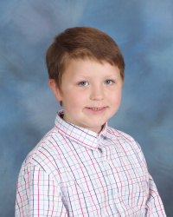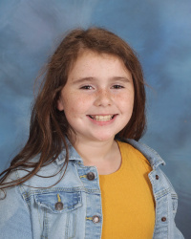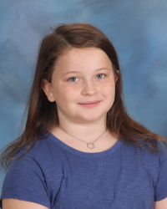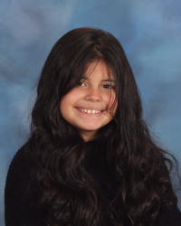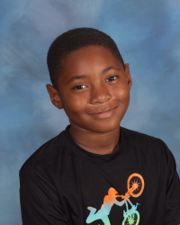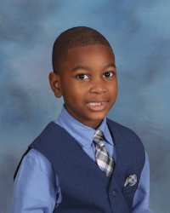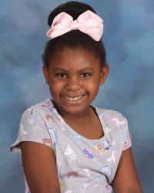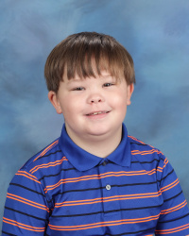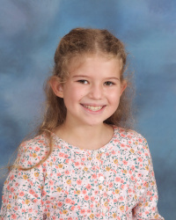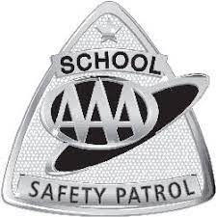

**Bryson Conner Sergeant 4th Grade Mrs. Robinson**

**Elizabeth Bailey**

**Sergeant 4th Grade Mrs. Robinson**

**Ansleigh Kilgore Lieutenant 4th Grade Mrs. Robinson**

**Kendall Bagwell Captain 4th Grade Mrs. Robinson**

**Sasha Moore 3rd Grade Ms. Merrill**

**McBean Elementary Paw Patrol**

**2022-2023**

**Ivory Lopez 3rdGrade Mrs. Brown**

**Khaleb Jordan 3rd Grade Mrs. Brown**

**Skylar Teston 3rd Grade Ms. Merrill**

**Trenton Maloy 3rd Grade Mrs. Wise**